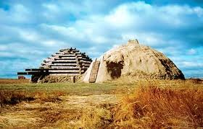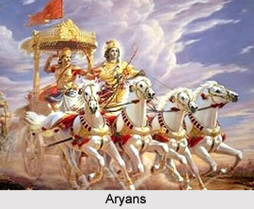

## Citation Page:

* "Ancient Aryan Civilization Achieved Incredible Technological Progress 40 Centuries Ago."*Ancient Aryan Civilization Achieved Incredible Technological Progress 40 Centuries Ago*. N.p., 16 Dec. 2013. Web. 16 Dec. 2013.
* "Aryans." *Aryans*. N.p., n.d. Web. 16 Dec. 2013.
* "Aryans and the Chariot Technologies." *Paintings I Love*. N.p., n.d. Web. 17 Dec. 2013.
* Boomer, Arya. "Aryan Civilization in Ancient India." *Prezi.com*. N.p., 29 May 2013. Web.
* "Pgapworld - Caste (varna) System." *Pgapworld - Caste (varna) System*. N.p., n.d. Web. 17 Dec. 2013.
* "Shunya's Notes." *'Shunya's Notes'* N.p., n.d. Web. 16 Dec. 2013.

(Above) Statue of a Rajah.

## Aryan Houses

Aryans are a nomadic culture. So, if you want to live in an Aryan village, you’ll need to be nomadic as well. Being nomadic puts certain restrictions on the type of house you can have. For example, you can’t make a nice stone house, because it would be expensive to have to make it each time you move. Therefore, typical Aryan houses are constructed out of wood and straw, which is a cheap, but effective, and easily movable form of construction.

# How to Live in an Aryan Village

## Structure of a Village

A typical Aryan village was a gana, meaning “collection”. Many families lived in the same gana, and people that were of higher status lived in larger homes. Each gana had its own territory, and its own war chief called a “rajah” ruled each gana. A rajah was a regional leader that was responsible for protecting his people, and was repaid in money or food.

By: Elijah Mroch

Period 1

Aryan Civilization

## Caste System, and your Role in the Community

## Yagna

Traditional Aryan homes had a central hearth, or as they are called by them, a “Yagna”. It is where the family members gather to discuss daily events and activities, or to eat their meals. It was also used to cook their meals, in which they used spits and bronze pots and pans. In your household, you will need to elect a family member to be in charge of fire. It is an important job, and the fire was thought to be a gift from Agni, the god of fire.

First off: a caste system is a type of social hierarchy utilized in Aryan culture. To live in an Aryan village, you will need to know what caste you are in, and what jobs you are applicable for, in accordance to your class. The four main Varnas (term for the classes) are believed to come from the body of a single entity. The body part they come from symbolizes their function.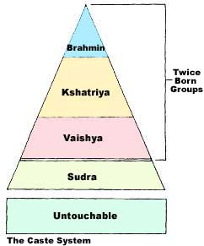

## Different Castes

### Brahmin

This is the upper class, and the smallest class, and is made up of priests and teachers. This Varna is represented by the mouth.

### Kshatriyas

This is a higher-ranking class, and is made up of warriors and rulers. It is represented by the arms.

### Vaisyas

This is made up of the common people. People in this class work as traders, herders, etc. They were represented by the thighs.

### Sudras

This is the lower class. They are servants and their duty is to wait upon those of the upper class. They are represented by the feet.

### Untouchables

People in this class were at the dead-bottom of society. They did all the jobs no one else wanted to do, such as dealing with corpses.

## Aryan Villages

So, if you want to live in an Aryan village, you need to know all of these cultural, structural, and spiritual tips. Even though very complicated, if the nomadic lifestyle is for you, then living in an Aryan village would be pretty good.

